***SGD LAB EXP – 4***

**Name** : Aditi Chhajed; **Reg. No.** : 221081009

**Branch** : IT ; **Course Instructor** : Prof. Vedashree Awati

Name : Aditi Chhajed

Reg.No : 22108100

***Aim:***

*Spatial select queries.*

***Implementation:***

1. *Creating a database first.*

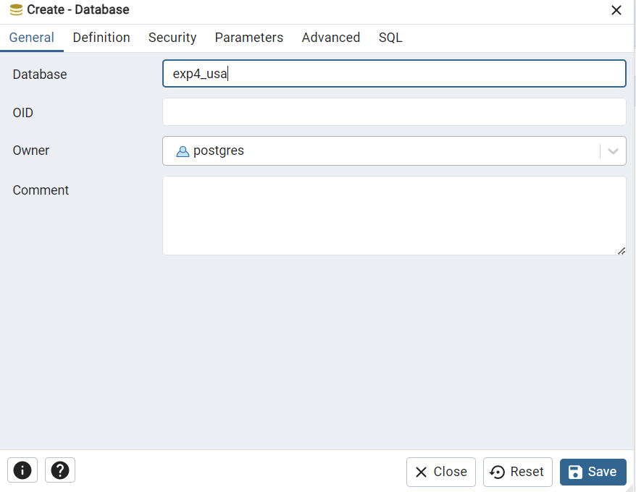

1. *Establish connection and see the successful connection message.*

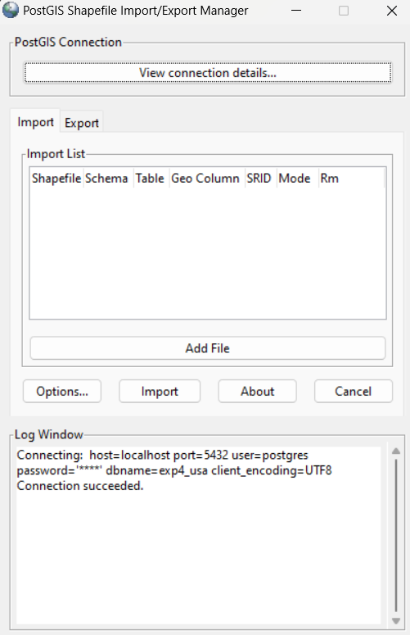

1. *Import Shapefiles*

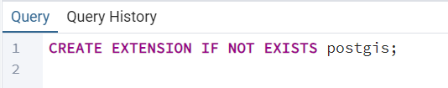

*(first create a connection)*

*Navigate to c:\Program Files\PostgreSQL\15\bin\postgis gui and run*

*executable file shp2pgsql-gui.exe*

*● Click on view connection details*

*● Enter username as postgres, password, server host as localhost and port*

*as 5432 and database name is the same as that was created above in*

*step 1. After clicking on OK, it should give a message connection*

*succeeded.*

*● Select the add files option and select the shapefile. 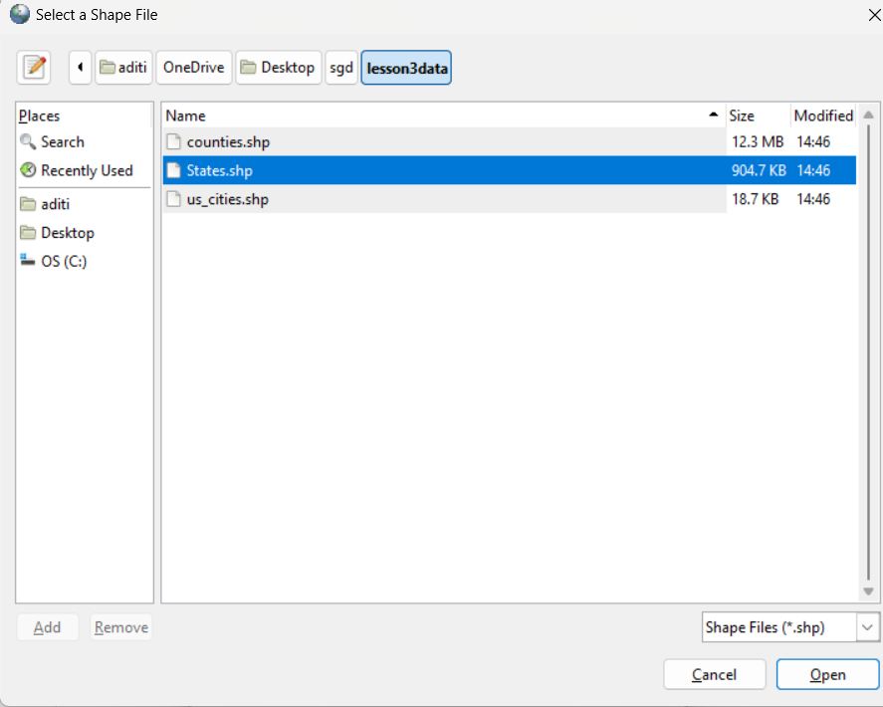*

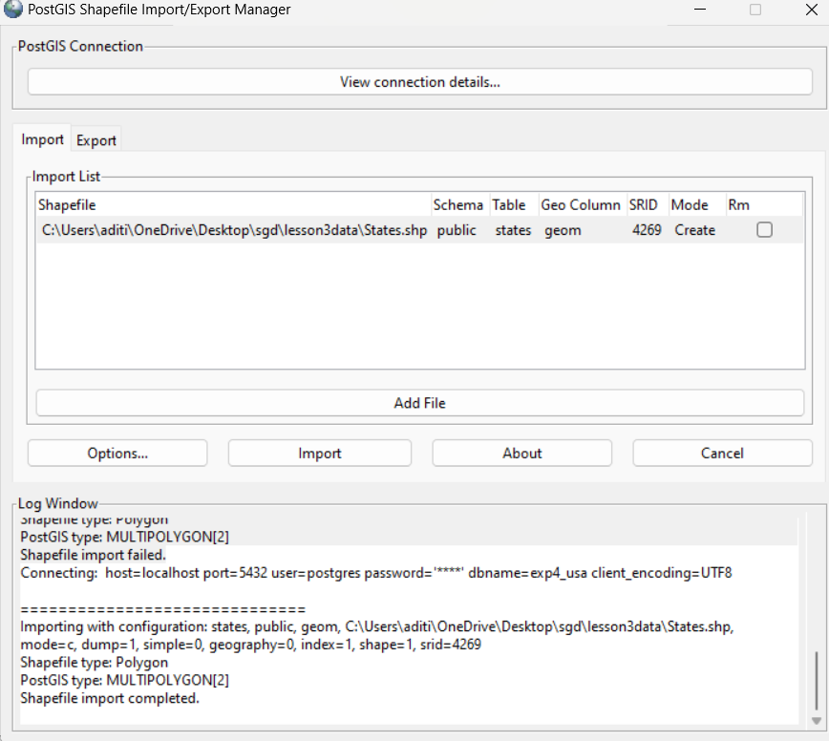

*Checking the loaded sql file.*

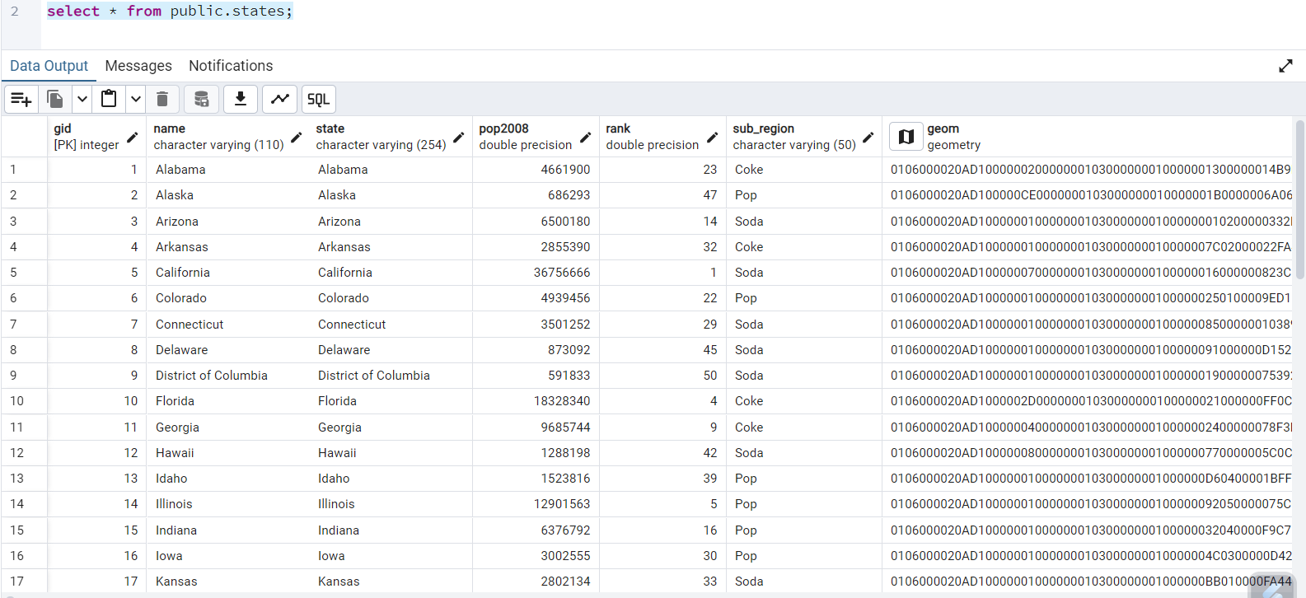

***Theory:***

***1. ST_Centroid(geom):***

*- Computes the geometric center (centroid) of a given geometry, typically a polygon.*

*- The output is in the coordinate system of the input geometry, often in hexadecimal format, which is hard to read.*

***2. ST_AsText(ST_Centroid(geom)):***

*- Converts the centroid’s coordinates to a readable format (longitude, latitude).*

*- This is useful for human-friendly display of geometric points.*

***3. ST_Area(geom):***

*- Calculates the area of a geometry. The units of the result are based on the geometry's spatial reference system.*

*- If the geometry uses latitude/longitude (degrees), the area will be in square degrees, which is unreliable for area calculation due to varying degree sizes across the globe.*

***4. ST_Transform(geom, SRID):***

*- Re-projects a geometry from its original spatial reference system to another, specified by the `SRID` (Spatial Reference Identifier).*

*- Example: Transforming to SRID `2163` (an equal-area projection in meters for the U.S.) enables more accurate area calculations in square meters.*

*- Note: `ST_Transform` changes the geometry only in the query, not in the table itself.*

***5. Using ST_Transform with ST_Area:***

*- By re-projecting geometries to an equal-area projection before calling `ST_Area`, we get accurate area calculations in square meters, which is essential for meaningful area measurement.*

*These functions and transformations provide essential tools for spatial analysis, enabling accurate area measurements, centroids, and readable output across varied coordinate systems.*

***Execution (Introduction to Spatial Select Queries):***

1. *First Query*

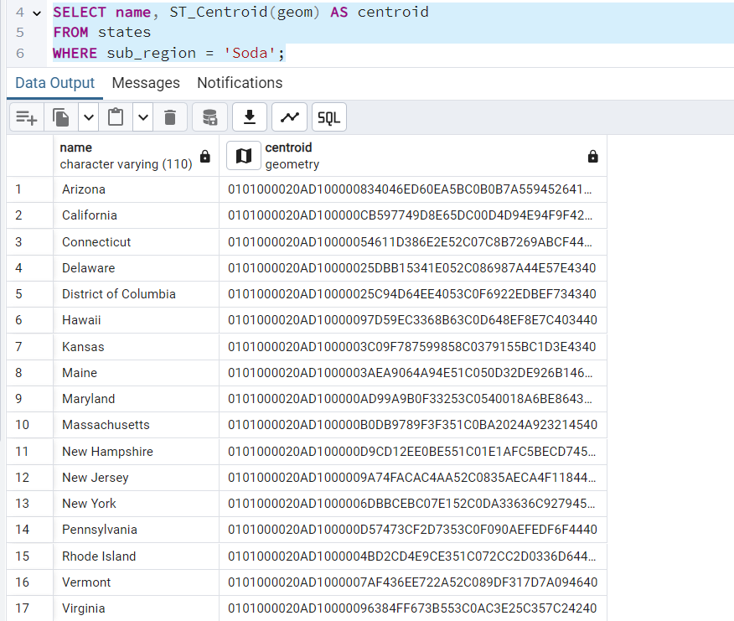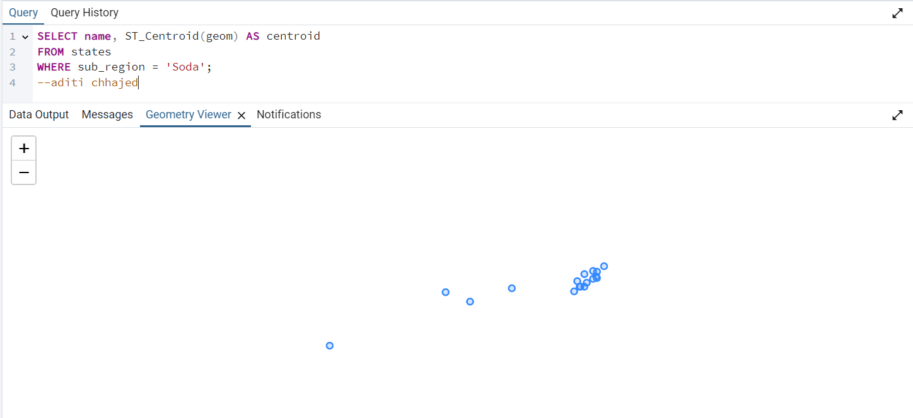

1. *Second Query.*

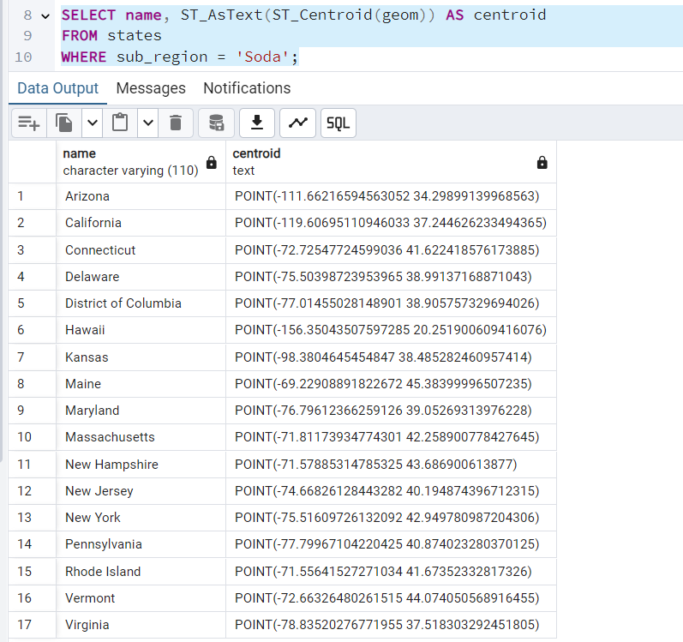

1. *Third Query*

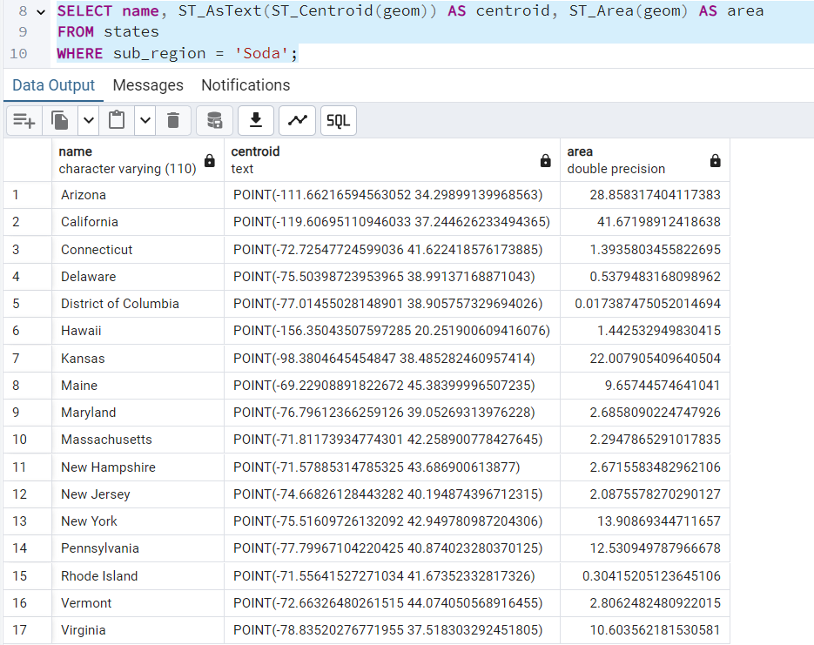

1. *Fourth Query*

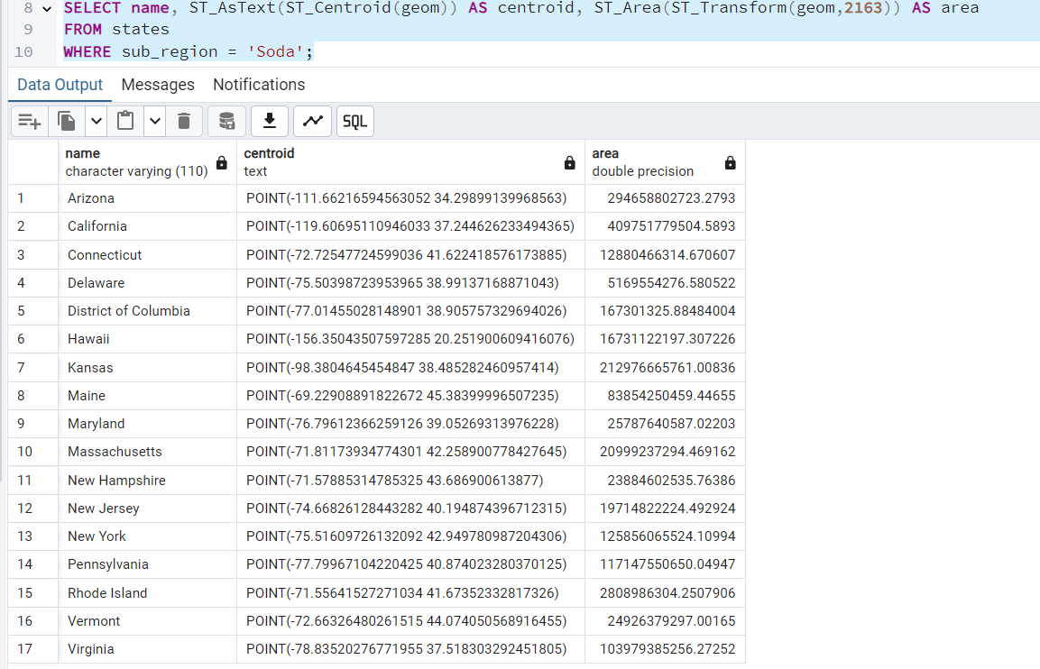

***Conclusion:***

*This experiment highlights the importance of accurate spatial reference systems (SRIDs) and geometry handling when performing spatial analyses in PostgreSQL/PostGIS:*

*1. Accuracy Over Shortcuts: Properly transforming data isn’t optional if we want reliable results. So, I took the time to project my data accurately; it matters, especially with real-world distances.*

*2. Geometry Types Matter: Choosing the right geometry (e.g., full boundary vs. centroid) based on the experiment analysis goal significantly changed the results .*

*3. Check Data Integrity: Always verify SRID and projection details first to avoid analysis errors. Data integrity sets the foundation for meaningful results.*

*These points underscore the importance of precision, clarity, and foundational checks in spatial analysis which helped in the experiment.*